

BCSE417L – MACHINE VISION LAB

EXPERIMENT 6&7: Real-World Application of Python in Image Processing (histogram equalization, Sobel and Canny filters)

SUBMITTED BY-
22BAI1118 – Mayank Raj

SUBMITTED TO-
Trilok Nath Pandey
Date: 23/02/2025
Task 1: Implement Histogram Equalization
Objective:
To improve the contrast of a grayscale image by applying histogram equalization without using OpenCV.
Input Image:

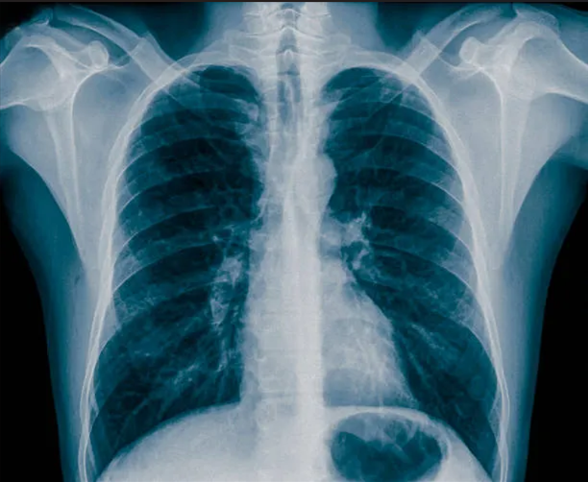
Method:
- Load the grayscale image.
- Generate the image histogram.
- Compute the cumulative distribution function (CDF).
- Normalize the CDF to scale intensity values within the range [0, 255].
- Apply the transformation for histogram equalization.
- Display both the original and equalized images for comparison.
Output Image:

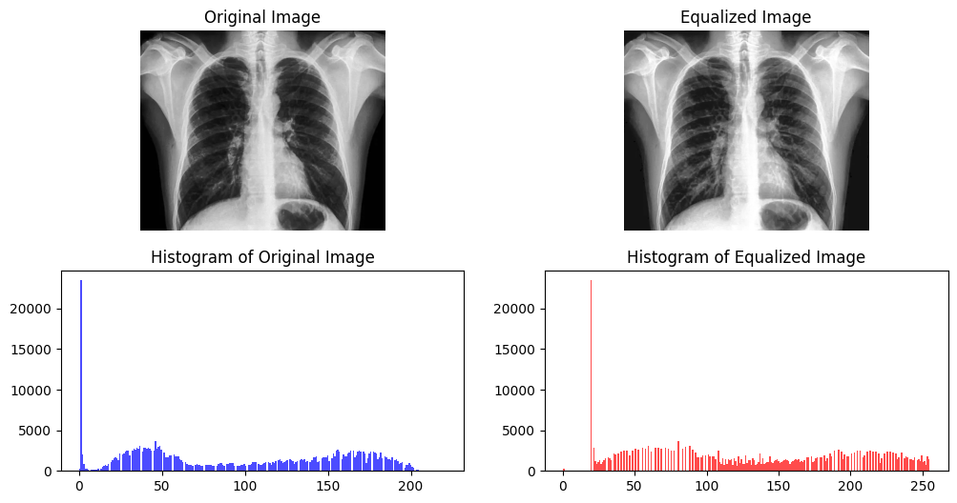
Conclusion:
Histogram equalization significantly enhances contrast by redistributing pixel intensities across the image. The resulting transformation improves visibility, as confirmed by histogram analysis. However, in certain cases, over-enhancement may occur.

Task 2: Compare Sobel and Canny Edge Detection Methods (60 Marks)
Objective:

To analyze and compare the effectiveness of Sobel and Canny edge detection techniques on images with varying edge complexities.
Input Images:
- Simple Edge Image
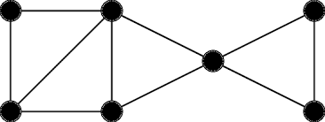
- Complex Edge Image
  - 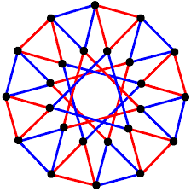
Method:
- Load two images—one with simple edges and another with complex edges.
- Apply theSobel edge detection algorithm.
- Apply the Canny edge detection algorithm.
- Display and compare the resulting edge-detected images.
Output Image:
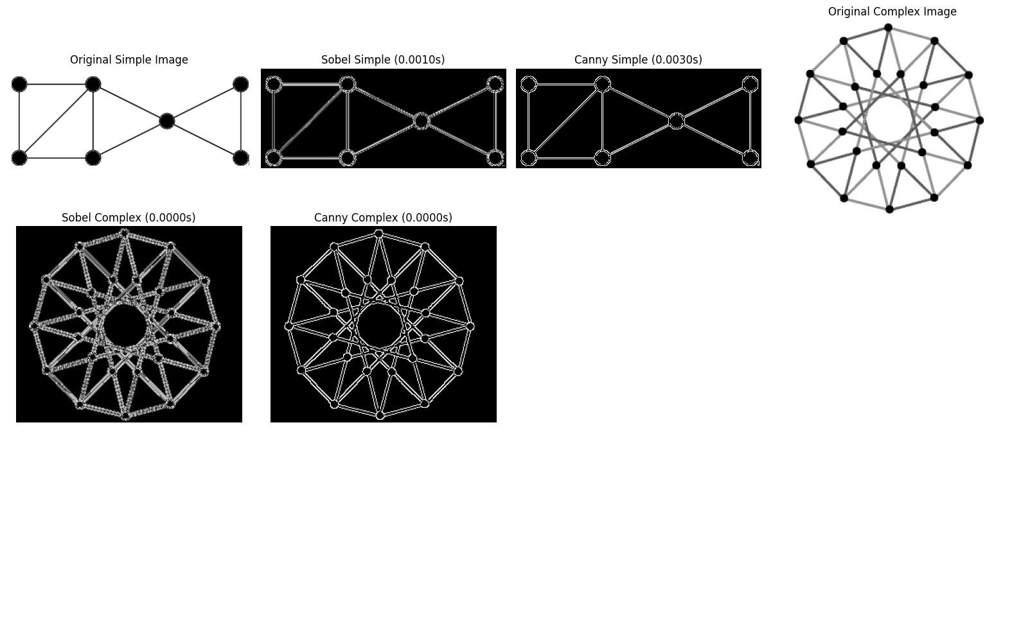
Analysis and Comparison:
Edge Clarity and Continuity:
- Sobel produces well-defined edges but may lack continuity.
- Canny generates sharper and more connected edges.
Sensitivity to Noise:
- Sobel is more vulnerable to noise due to its reliance on gradient calculations.
- Canny incorporates Gaussian smoothing, enhancing noise resistance.
Computational Performance:
- Sobel operates faster since it follows a simpler computational approach.
- Canny is slower due to additional steps, including gradient calculation, non-maximum suppression, and hysteresis thresholding.
Conclusion:
Both techniques offer distinct advantages depending on the application. Sobel is an efficient choice for quick edge detection but is more noise-sensitive. In contrast, Canny provides superior edge clarity and robustness to noise at the cost of increased processing time. The selection between these methods depends on the specific requirements—Canny is preferred for high-precision tasks, while Sobel is suitable for real-time applications where speed is crucial.

